Tuya Cloud Serial Debugging Tool Instructions
- Software instructions
The software only supports <Tuya Cloud General Serial Debugging Tool Communication Protocol> and assists in the development of <Tuya Cloud General Serial Debugging Tool Communication Protocol>.
- Instructions of the software operating environment
The software needs to be used in the Windows system with Microsoft .NET Framework 4.0 operating environment. If your computer doesn’t have the environment, please click on dotNetFx40_Full_x86_x64.exe to install it.
3. Using guide of the software
3.1 Software user interface：
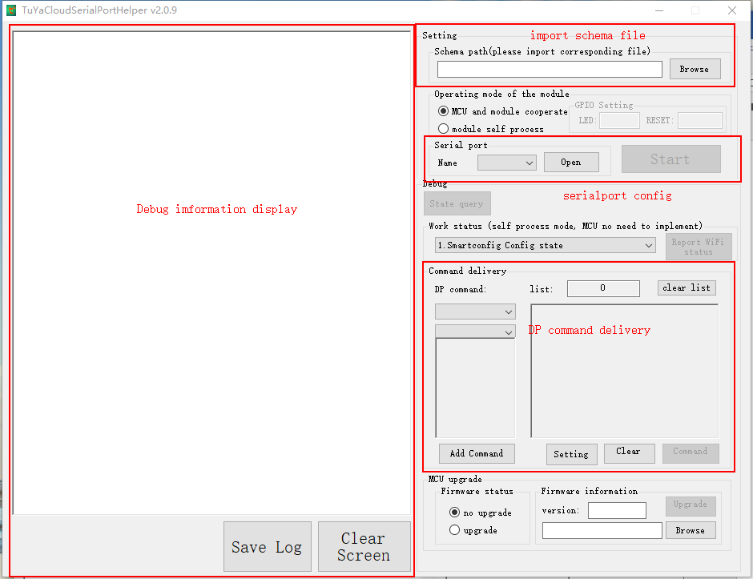

3.2 Using guide details
1) Open serial port. The baud rate for serial communication is fixed at 9600Bd/s. After serial port is opened, enter hex command in the dialog box and send it.
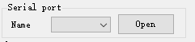
2) Load schema file. The Schema file must be a .json file that conforms to Tuya DP command.
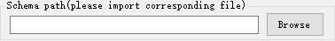
3) When serial port is successfully opened and schema file is successfully loaded, the software will automatically generate the corresponding DP command.
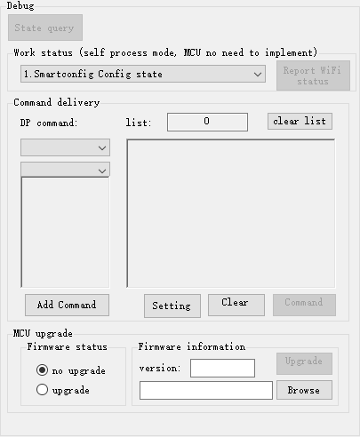

4) When the software receives data, it will automatically parse data according to the schema file and then display the result. Click on “Save” button and the software will automatically save the debugging information to the logs.txt file where the software is located.
